Lab Submission: 7

Student Name: Michael Daly

Course and Section: CST8215 – 362

========================================================================

Lab 7 – Creating User Defined data types and domains

Besides the built-in [data types](http://www.postgresqltutorial.com/postgresql-data-types/), PostgreSQL allows you to create user-defined data types through the following statements:

* CREATE DOMAIN creates a user-defined data type with constraints such as NOT NULL, CHECK, etc.
* CREATE TYPE is often used to create a composite type used in the [stored procedures](http://www.postgresqltutorial.com/postgresql-stored-procedures/) as the return data type.

<http://www.postgresqltutorial.com/postgresql-user-defined-data-types/>

In this Lab, you will run the DDL statements provided.

Grading: Lab 7 is worth 5 marks

========================================================================

Step 1

Run the following DDL statements, using PGAdmin Query Tool

DROP TABLE IF EXISTS Canada_Post_T;

DROP DOMAIN IF EXISTS Canada_PostCode_D;

-- domain will allow valid string of

-- characters and numerals as postcode

CREATE DOMAIN Canada_PostCode_D AS TEXT

CHECK(

VALUE ~ '[A-Z][0-9][A-Z][0-9][A-Z][0-9]'

);

CREATE TABLE Canada_Post_T(

Address_ID SERIAL PRIMARY KEY,

Street1 TEXT NOT NULL,

Street2 TEXT,

City VARCHAR( 25 ) NOT NULL,

PostCode Canada_PostCode_D NOT NULL

);*Provide screenshot here, showing new domain and table created (be sure to expand table to fully show columns in this new table*

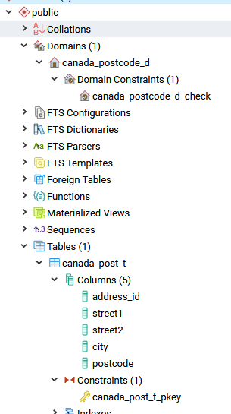

Step 2

Run the following DML statements, using PGAdmin Query Tool

DELETE FROM Canada_Post_T;

-- Successful

INSERT INTO Canada_Post_T( Street1, City, PostCode )

VALUES( '1385 Woodroffe Avenue', 'Ottawa', 'K2G1V8' );

-- Unsuccessful INSERT operation

INSERT INTO Canada_Post_T( Street1, City, PostCode )

VALUES( '1385 Woodroffe Avenue', 'Ottawa', 'K2g1V8' );

-- Unsuccessful INSERT operation

INSERT INTO Canada_Post_T( Street1, City, PostCode )

VALUES( '1385 Woodroffe Avenue', 'Ottawa', 'K21V8' );

-- Unsuccessful INSERT operation

INSERT INTO Canada_Post_T( Street1, City, PostCode )

VALUES( '1385 Woodroffe Avenue', 'Ottawa', '2K31V8' );

*Provide screenshot here, showing the error messages that occur when executing these DML statements.*

